|  |  |  |
| --- | --- | --- |
| **دولة فلسطين**  **وزارة التربية والتعليم العالي**  **مدرسة الاسراء لبنات سنجل الثانوية**  **وقت الامتحان : ساعة و نصف** | **Palestine** | **English Language**  **Date**: **01\02\2023**  **Class**: 11 th (A, B)  **Unit 7 Exam** |
| **Name: ……………………………………………..** | | |

**Reading**

**Read the following passage and answer the questions below.**

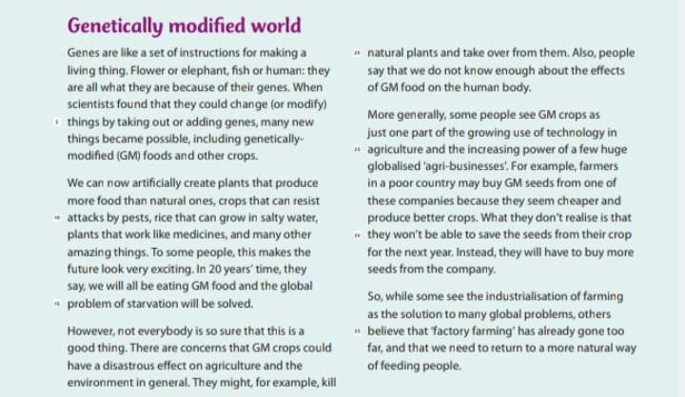

**A. Answer these questions:**

1. What makes things the way they are?

…………………………………………………………………………………………………

1. What will happen in 20 years time?

………………………………………………………………………………………………….

1. What is the problem of buying Gm seeds?

………………………………………………………………………………………………….

**B. mark the sentences true ( ✔ ) or false ( ✘ ).**

1. Scientists can’t change genes ( )
2. All people agree with GM crops ( )
3. Factory farming has gone too far to some people. ( )

**C. the pronoun** “**they”** line 4 refers to ………………………………….

D. A word that means “ fight back against” .............................................................

**vocabulary**

**1. Match the words with their meaning .**

|  |  |  |  |
| --- | --- | --- | --- |
| **1** | **additives** |  | **Normal, always the same** |
| **2** | **ingredients** |  | **Insects and ither animals that harm crops** |
| **3** | **standard** |  | **Extra things** |
| **4** | **pests** |  | **worries** |
| **5** | **concerns** |  | **Things you need to make a meal** |

**1. Complete these sentences from the box.**

|  |  |  |  |  |  |
| --- | --- | --- | --- | --- | --- |
| seeds | disastrous | starvation | flavors | reaction | fresh |

1. I love eating salad, that is made of ……………………. vegetables.
2. I’m not talking to you as a ……………… to your behavior with me.
3. He needs to put……………………. In the soil in order to grow plants.
4. This gum has many …………………. . My favorite is strawberry.
5. Gaza people are suffering from ……………….. in addition to death

**2. Choose the best form of the word to complete the sentence ( noun, verb, adjective).**

1. **My house is built on the………………… way. ( modern)**
2. **Don’t ………………… your speech. (general)**
3. **…………………. Isn’t a thing that I prefer.( social)**
4. **They usually …………………. Bed sizes. ( standard)**
5. **English is a ……………………… language. (global)**

**Language**

1. Complete the following sentences with the correct future form of the verb.
2. I’m busy, I …………………. ( talk) to you later.
3. Call her after 15 minuets, she …………………. (eat) her dinner.
4. I need more time, I…………………….. ( not\ finish) the project by the morning.
5. I’m sorry I cant come with you, I………………………… ( study) for my exam.
6. If he says no, she……………….. (not\go) alone.
7. In 2025 , You ………………………. (study) for Tawjihi.
8. In 20.07 , I ……………………. ( not\be) married for 7 years

**writing**

Write about one of the following topics.

1. Help me make a meal, write the recipe please.
2. Explain how a tool works.
3. Gaza Flag Of Palestine Gaza Strip Flag Themes Free Stock Photo - Public ...Flag Of Palestine Gaza Strip Flag Themes Free Stock Photo - Public ...Flag Of Palestine Gaza Strip Flag Themes Free Stock Photo - Public ...Flag Of Palestine Gaza Strip Flag Themes Free Stock Photo - Public ...Flag Of Palestine Gaza Strip Flag Themes Free Stock Photo - Public ...Flag Of Palestine Gaza Strip Flag Themes Free Stock Photo - Public ...

…………………………………………………………………………………………………………………………………………………………………………………………………………………………………………………………………………………………………………………………………………………………………………………………………………………………………………………………………………………………………………………………………………………………………………………………………………………………………………………………………………………………………………………………………………………………………………………………………………………………………………………………………………………………………………………………………………………………………………………………………………………………………………………………………………………………………………………………………………………………………………………………………………………………………………………………………………………………………………………………………………………………………………………………………………………………………………………………………………………………………………………………………………………………………………………………………………………………………………………………………………………………………………………………………………………………………………………………………………………………………………………………………………………………………………………………………………………

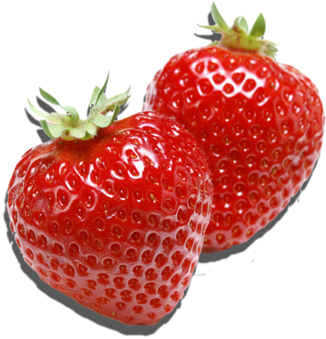

[This Photo](https://pngimg.com/download/88) by Unknown Author is licensed under [CC BY-NC](https://creativecommons.org/licenses/by-nc/3.0/)

Good Luck

Shaima’a Rummaneh